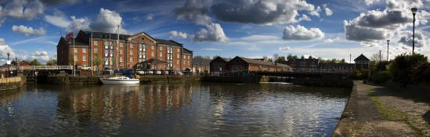

Funeral/Wakes
Holiday Inn
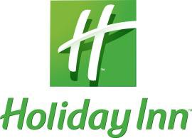
Ellesmere Port/Cheshire Oaks

Funeral teas, wakes and memorial parties can be both moving and uplifting events. Our team at the Holiday Inn Ellesmere Port/Cheshire Oaks has many years’ experience in sympathetically attending to funeral requirements at this most difficult time, ensuring that they do not add to the stress of losing a family member or close friend. With the greatest of sympathy and compassion we will help you to organise your funeral wake with empathy and consideration to your family.

Our staff recognises the importance of events such as funerals & memorials, and can organise catering, musicians and anything else you may require - on the day itself, will provide a sympathetic, discreet and efficient service for the bereaved family during this difficult time.
.

Menu A
Various closed ciabattas served with chips and homemade coleslaw
Tea & Coffee

£13.50 per person

Menu B
Various filled tortilla wraps served with potato wedges, homemade coleslaw and vegetable samosas
Tea & Coffee

£14.50 per person

Menu C
Various filled baguettes and closed Ciabatta’s,
Potato wedges, Homemade Coleslaw,
Fried Chicken pieces
Selection of tea time cakes
Tea & Coffee
£18.50 per person
Holiday Inn Ellesmere Port/Cheshire Oaks Lower Mersey Street, Ellesmere Port, Cheshire, CH65 3AL T: 0151 356 8111 F: 0151 356 8444
Email: enquiries@hiellesmereport.com Web: www.hiellesmereport.com

Extra’s
£4.25 Per serving mini steak pie (min 30 portions)
£4.95 Per serving chicken tikka split sticks (min 25 portions)
£9.95 per serving lamb scouse (min 30 portions)
£8.95 per serving chilli and rice (min 30 portions)
£5.25 per serving individual tea time cakes

